Nightingale Music

Design and Specification Document

# Design

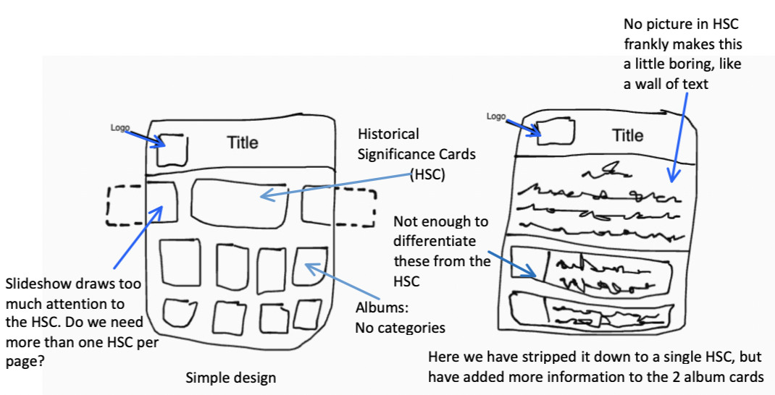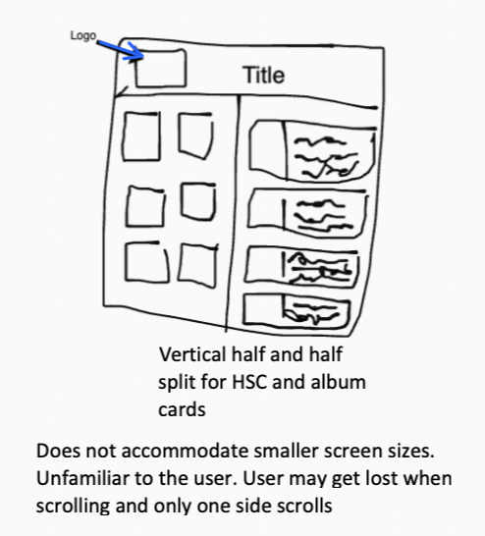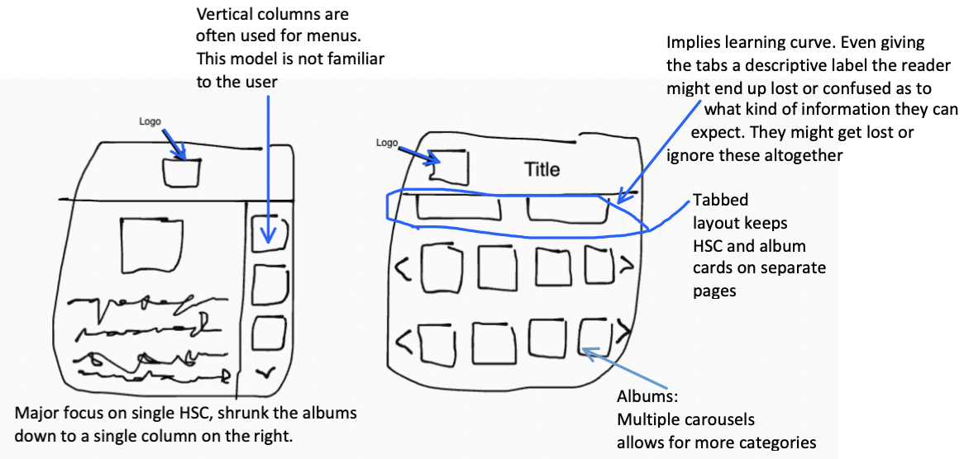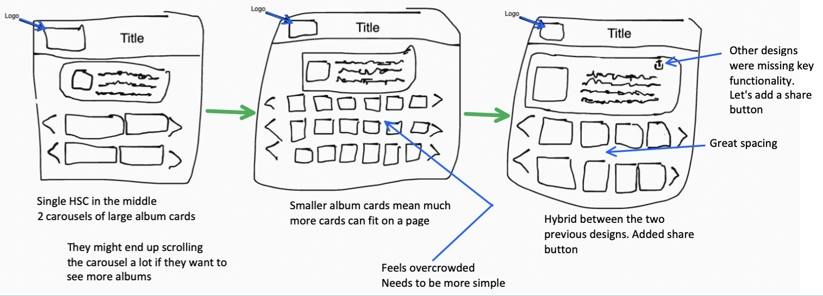

# Prototypes

# 

# 

# 

# 

# Specification

# Supplement traditional online music discovery with details highlighting a particular album’s significance both within a user’s inner circle of friends and the larger worldwide music community. The up-front social sharing and historical significance callouts are visible, inviting, and intuitive for the user without over complicating a quick purchasing decision.

## Persona

Angelina is a Cuban-born 36 year old immigrant who lives with her husband and two daughters age 18 and 16 and one son age 8. She mostly uses the internet to connect with friends and family back home.

She spends more time than she would like bouncing between Wikipedia articles and her local music store because frankly she does not want to buy music unless she really likes it and knows it will be good for her family.

## Scenario

Angelina is relieved that it is finally Friday. With her and the kids out of school they finally have some downtime to spend together as a family. She remembers that one of her classmates today recommended that she look into a new community-focused online music store.

Before long she has the clean website in front of her. She is delighted when she sees an upcoming latina artist is featured on the front page with a little Wikipedia excerpt about her. After reading the excerpt she clicks through to explore their songs and maybe even buy one or two. Seeing the first song has very high ratings and is on sale for cheap she decides to buy it. She recalls from the Wikipedia article that she saw the star on the popular talk show, Ellen. She remembers it was on in the breakroom at work and had a fun conversation about it with her coworker Kevin. She wants to share the song with Kevin. Surprisingly, this is also very easy and as she clicks the share button her friends name pops up. She clicks on him and pushes send. She is so ecstatic.

## Criteria

|  |  |  |
| --- | --- | --- |
| P1   * The user can find information that will help them make an informed decision about the album they are looking at | P2   * The user is confident in purchasing music even if they later find they do not like the music * The user is familiar with the process of purchasing music from similar experiences on other sites | P3   * The user does not get confused by the combined social and commerce aspects of the site |

## Snapshot

## 

*Homepage*

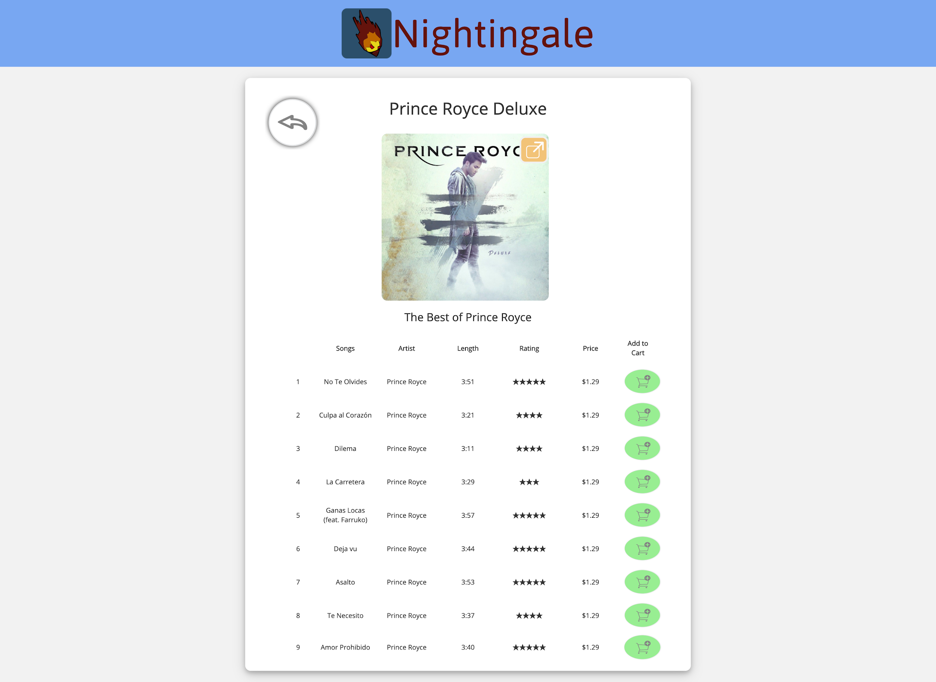

*Playlist details screen*

# 

Default

Hover

Pressed

Pressed

Hover

Default

Default

Hover

Pressed

Pressed

Hover

Default

Default

Hover

Pressed

Pressed

Hover

Default

Pressed

Hover

Default

Default

Hover

|  |  |  |  |
| --- | --- | --- | --- |
| Icon/Button | Background (RGB) | Foreground (RGB) | Border (RGB) |
| Back | (255,255,255) | (131,131,131) | (236,236,236) |
| Carousel cycle left | (255,255,255) | (131,131,131) | (236,236,236) |
| Carousel cycle right | (255,255,255) | (131,131,131) | (236,236,236) |
| Share button | (111,176,202) | (255,255,255) | (236,236,236) |
| Send | (96,158,65) | (122,127,120) | (82,130,54) |
| Cancel dialog | (235,235,235) | (122,127,120) | (146,146,146) |
| Not in cart/ Add to cart | (242,257,56) | (131,131,131) | (236,236,236) |
| In cart/ Remove from cart | (105,225,68) | (131,131,131) | (236,236,236) |
| Logo | (29,49,59) | Complex svg bird’s head | Transparent |
| Friends icon | Transparent | (0,0,0) | Transparent |
| Wikipedia icon | Transparent | Complex svg wikipedia logo | None |

* Header
  + 120 pixels tall
  + Light blue background (220,232,250)
  + Contains 2 objects
    - Logo
    - Title
      * Open Sans, black, size 38 pt
* Historical Significance Cards
  + 250 pixels tall/ 80% of webpage width wide
  + Light blue background (88,202,250)
  + Contains 5 Objects
    - Album Art
      * 120 pixels by 120 pixels
    - Heading
      * Open Sans, black, size 20 pt
    - Paragraph text
      * Open Sans, black, size 12 pt
    - Source Information Icon (Wikipedia)
      * Text is LinLibertineC font, black, size 13 pt
    - Share Button
* 2 Album Carousels
  + Contains 10 objects
    - Cycle left button
    - Cycle right button
    - 6 Album cards
      * All labels are blue (49,130,247) Open Sans, size 9 pt
      * Wrapped in rounded rectangle with 45 degree curve radius, white inside, thin 2 pixel wide grey (216,216,216) border
      * Contains 4 objects
        + Album Art

Size 40 pixels by 40 pixels

* + - * + Title label
        + Author Label
        + Price label
    - Heading
      * Open Sans, black, size 20 pt
    - Share Button

# 

# Appendix

## Bone-yard

There has been a change to the colors of the buttons on the page for a more consistent

# Rubric

**06 Ponder : Specification**

|  |  |  |  |
| --- | --- | --- | --- |
| **Criteria** | **Ratings** | **Pts** |  |
| This criterion is linked to a Learning Outcome  Design Process | |  |  |  |  |  | | --- | --- | --- | --- | --- | | **10.0 pts**  **Exceptional**  The design process shows creativity, structure, and introspection. Following this method, a high quality product will likely result every time | **9.0 pts**  **Good**  Evidence of broad thinking (breadth-first search), and systematic refinement (depth-first search) exists | **7.0 pts**  **Acceptable**  It is clear that the design when through multiple iterations, each of which improving the quality of the design | **5.0 pts**  **Developing**  More than one version of the design is present | **0.0 pts**  **Missing**  Only one design is present | | 10.0 pts |  |
| This criterion is linked to a Learning Outcome  Prototype | |  |  |  |  |  | | --- | --- | --- | --- | --- | | **20.0 pts**  **Exceptional**  The prototype unambiguously describes how each aspect of the design works. | **18.0 pts**  **Good**  All the features in the design are described to some degree | **14.0 pts**  **Acceptable**  Prototype capture the key design features but minor details are missing | **10.0 pts**  **Developing**  Flaws in the prototype seriously undermine its effectiveness | **0.0 pts**  **Missing**  Prototype missing | | 20.0 pts |  |
| This criterion is linked to a Learning Outcome  Design Quality | |  |  |  |  |  | | --- | --- | --- | --- | --- | | **20.0 pts**  **Exceptional**  All the priority 1 criteria are met and most of the priority 2 criteria are met | **18.0 pts**  **Good**  The target user is likely to be “pleased” with the design and all their needs will be met | **16.0 pts**  **Acceptable**  Minor flaws exist but none are likely to present serious usability issues | **10.0 pts**  **Developing**  Flaws in the design exist that seriously undermine how the user will accept the final product | **0.0 pts**  **Missing**  It is better to start from scratch; few parts of the design can be salvaged | | 20.0 pts |  |
| This criterion is linked to a Learning Outcome  Specification: Page 1 | |  |  |  |  |  | | --- | --- | --- | --- | --- | | **20.0 pts**  **Exceptional**  The “page 1” part of the spec completely and concisely capture all aspects of the design | **18.0 pts**  **Good**  All parts of the “page 1” part of the spec are well executed | **16.0 pts**  **Acceptable**  One or more component has a minor flaw but the essence of the design is communicated | **10.0 pts**  **Developing**  Everything is present but a serious flaw exists in one or more component seriously undermine its effectiveness | **0.0 pts**  **Missing**  One or more components of the specification is missing | | 20.0 pts |  |
| This criterion is linked to a Learning Outcome  Specification: Detailed Design | |  |  |  |  |  | | --- | --- | --- | --- | --- | | **30.0 pts**  **Exceptional**  Design is so clear and precise that there is no room for interpretation or confusion | **27.0 pts**  **Good**  Every detail has been worked out and is described in the spec | **24.0 pts**  **Acceptable**  All the design components are described in the spec to some degree | **15.0 pts**  **Developing**  One important aspect of the design is not completely hashed out | **0.0 pts**  **Missing**  No features are described to any degree of detail | | 30.0 pts |  |
| Total Points: 100.0 | | | |